Kubernetes (Minikube)

Steps to setup Minikube in windows:

1. Minikube runs on a virtual machine, so we can use VirtualBox or Hyper-V. In our case we will use VirtualBox, which we will install using the installer.

* ***https://www.virtualbox.org/wiki/Downloads***

1. Kubectl is a command-line tool that enables us to manage the cluster. We download the latest version of Kubectl from the official Kubernetes documentation website.

* ***https://kubernetes.io/docs/tasks/tools/install-kubectl-windows/***

1. We then download and install the latest version of Minikube from release pages on GitHub.

* ***https://minikube.sigs.k8s.io/docs/start/***

1. We run the following command on command prompt or PowerShell window to start Minikube.

* ***minikube start***

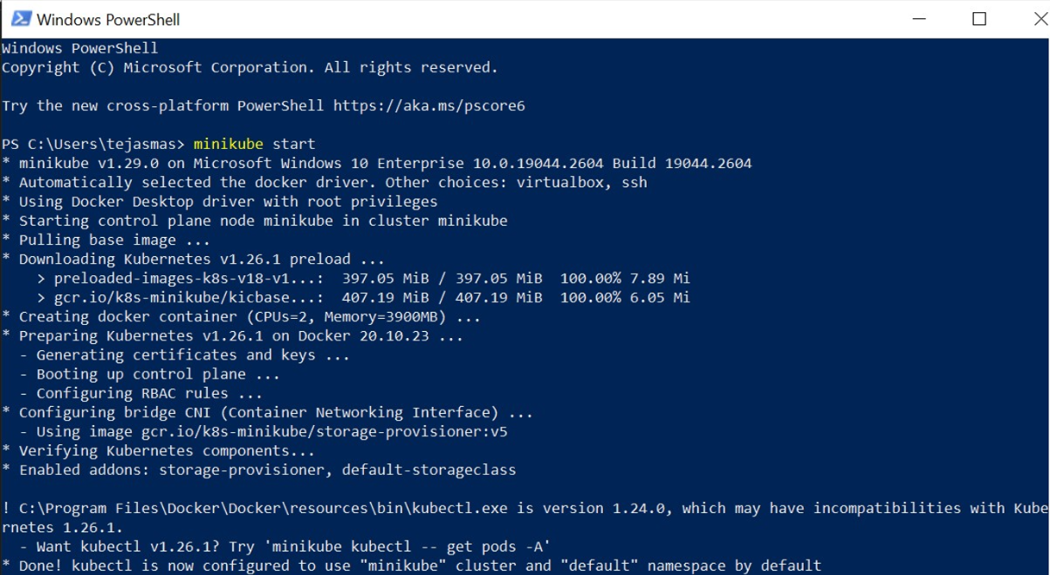

1. We verify the installation using the following command:

* ***minikube status***

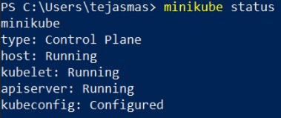

Steps to deploy a sample application on Minikube cluster

1. Create a deployment by defining a YAML file that describes the desired state of the deployment. Here's an example YAML file for a simple web application:

Save this file as **myapp-deployment.yaml**.

1. Apply the deployment: You can apply the deployment by running the following command:

* ***kubectl apply -f myapp-deployment.yaml***

1. To make the deployment accessible from outside the cluster, you need to create a Kubernetes service that maps to the deployment. You can create a service by defining another YAML file:

Save this file as **myapp-service.yaml**.

1. Apply the service: You can apply the service by running the following command:

* ***minikube service myapp-service –url***

This will display the URL you can use to access the application in your web browser.

